Underwriting >> New Transaction:

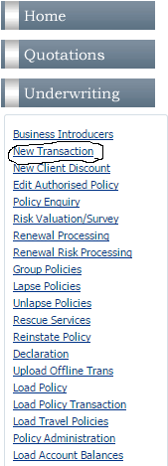

New Business:

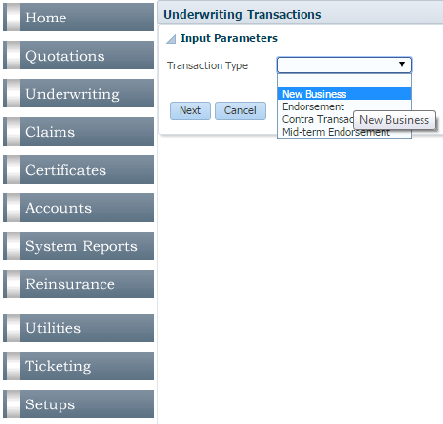 >> 

All you need to select on the next page is the client for whom you want to underwrite a policy:

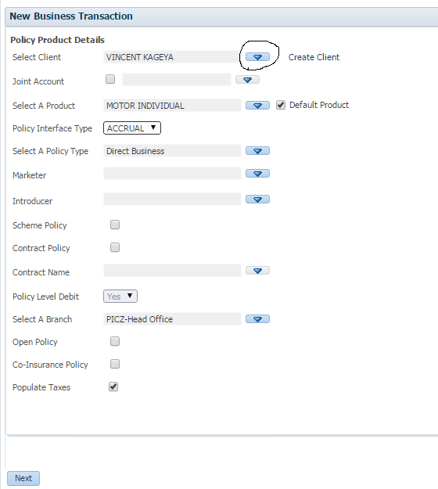 >

Define date when the policy starts. Select currency to underwrite in in this next page:

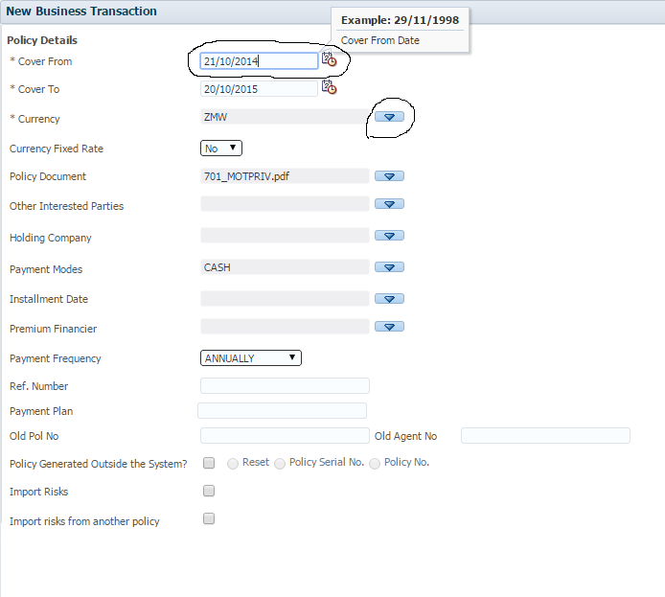

>> 

You may get a window like the one below where some policies have already been done for this client:

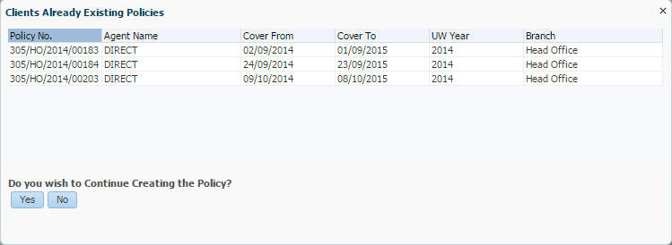

Select ‘*Yes*’ and continue.

System shows you the policy number that you are about to generate:

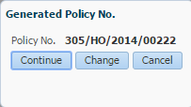 >> 

Define the Risk ID, which is usually the vehicles plate number (for a motor policy). Risk Description in that case will be the make of the vehicle being insured. Cover type: for ease, select *Third Party Only*:

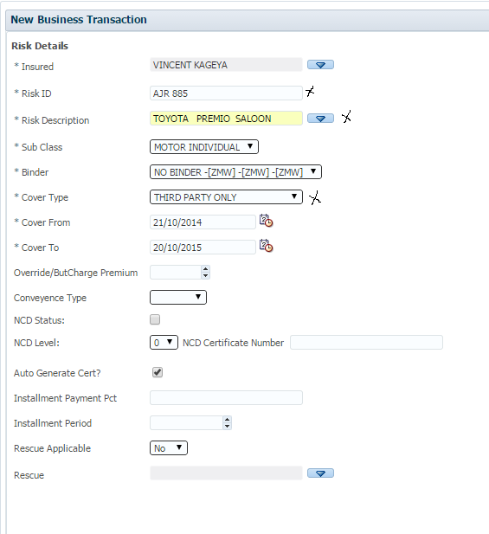

>> 

Risk Sections:

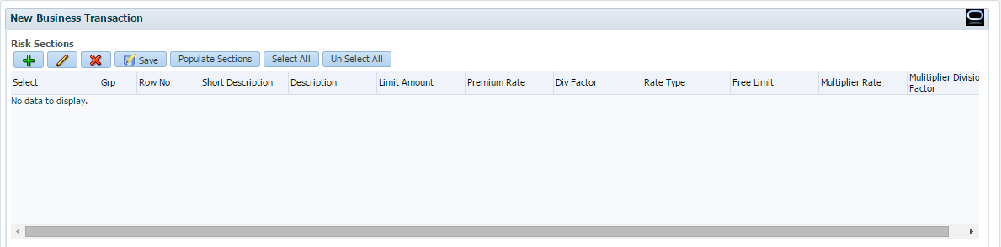

>> 

Select *Third Party Only*:

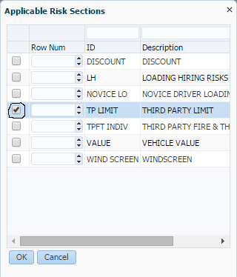 >> 

Default premium for this cover is ZMW 500:

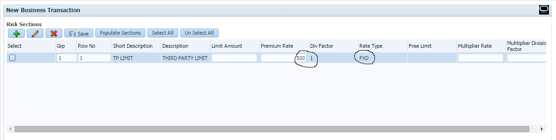

>> 

>> 

Risk Schedule Details:

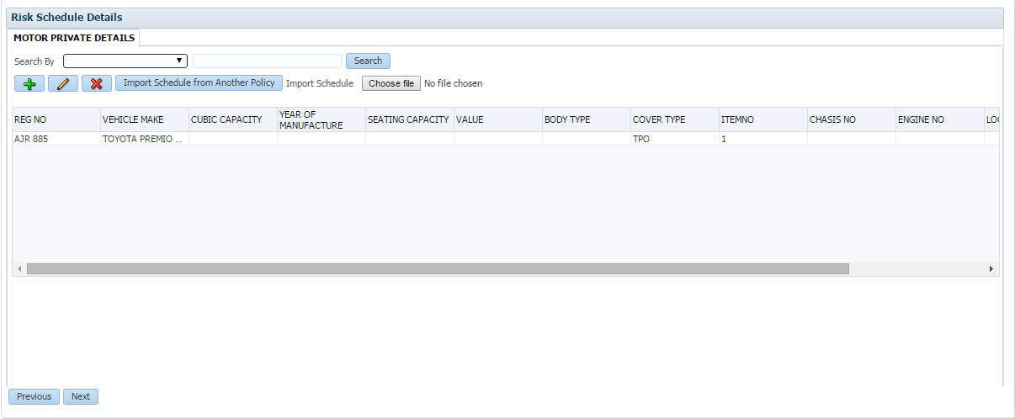

>> No amendments required: >>

Policy details in brief:

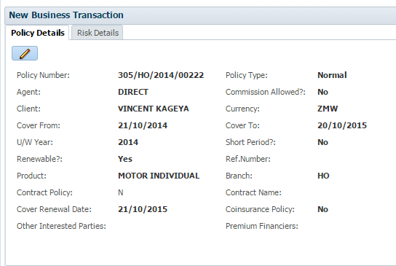 >> 

Compute Premium:

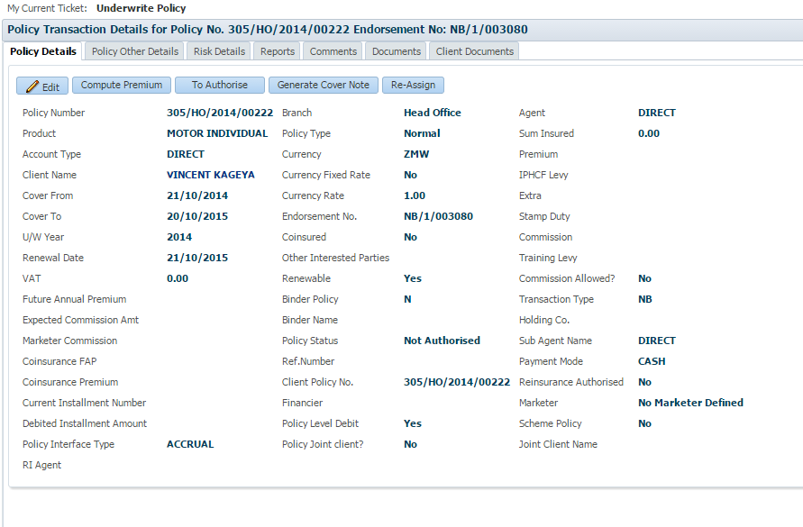

>> 

There is a bug in GIS: VAT on Premium is not computed the first time you click on *Compute Premium*:

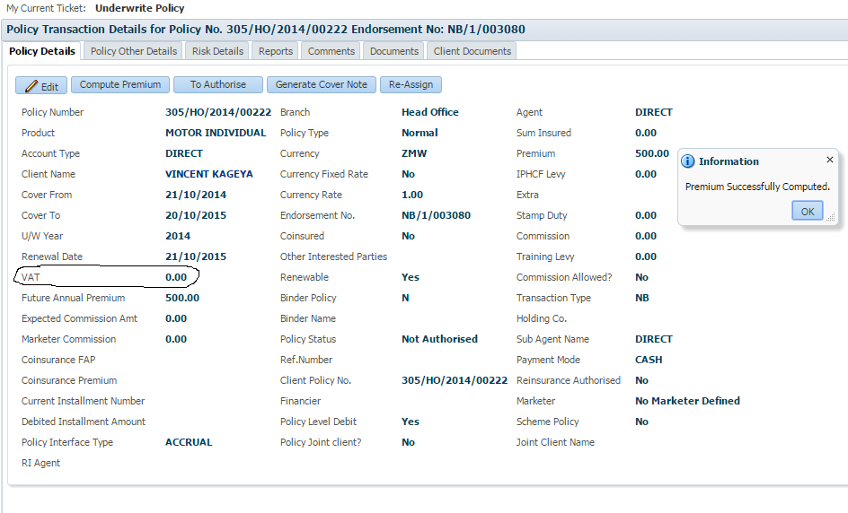

Click on  again. If VAT is still not computed, select;which takes you to the page below:

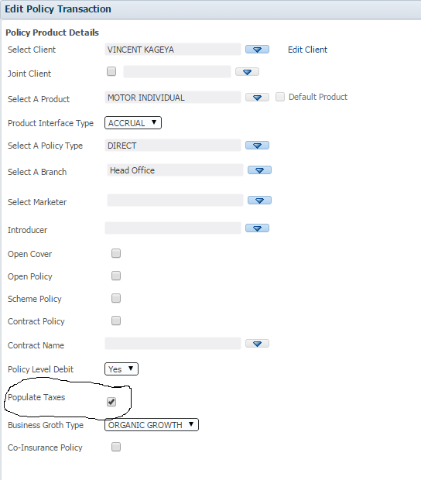

Check and uncheck the ‘*Populate Taxes*’ checkbox, then select .

Landing screen:

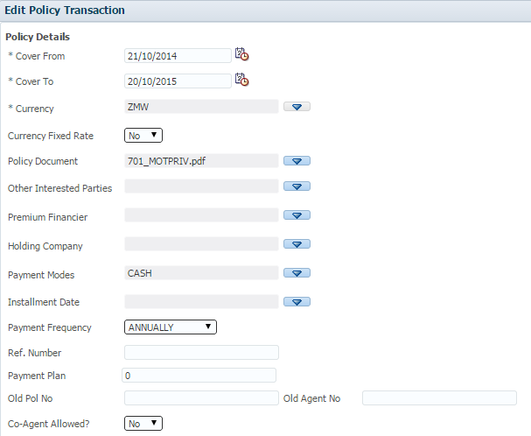

>> 

Compute premium again:

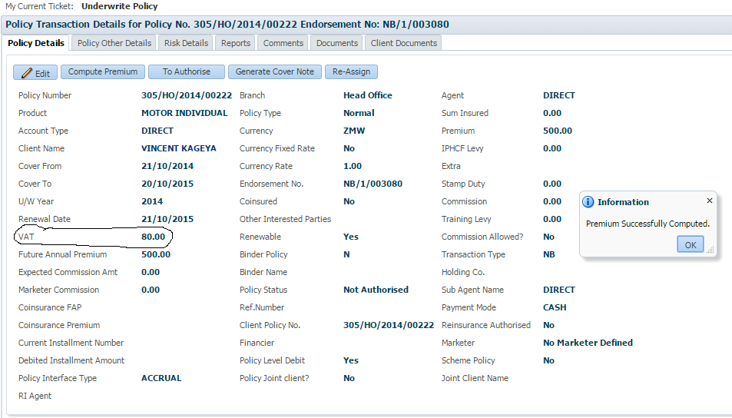

VAT has been computed successfully as above.

Authorize policy: >>

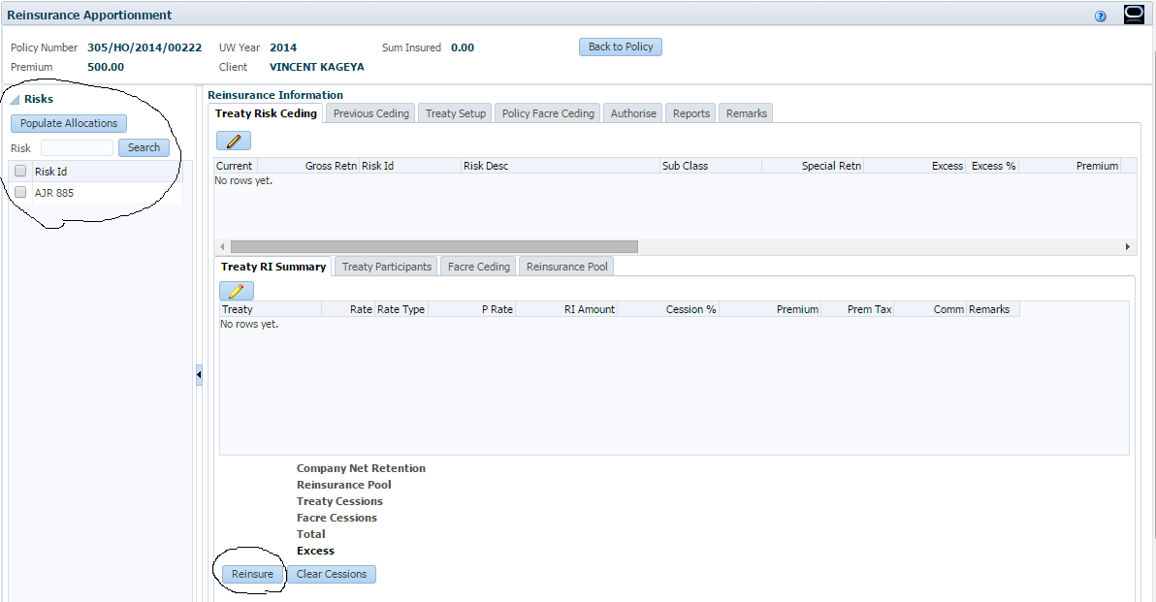

Select the Risk ID and ‘*Populate Allocations*’:

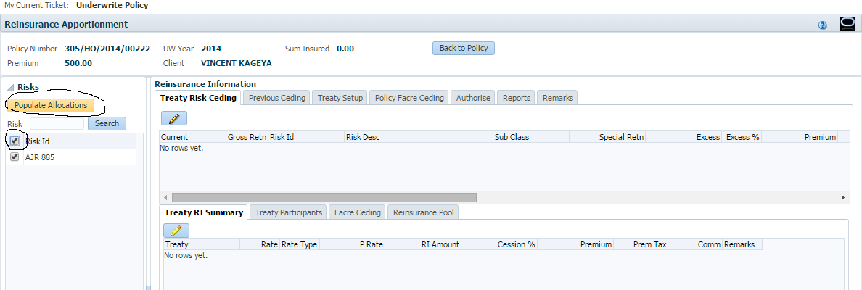

Once that’s done, highlight the risk ID (vehicle registration number) and click on ‘*Reinsure*’:

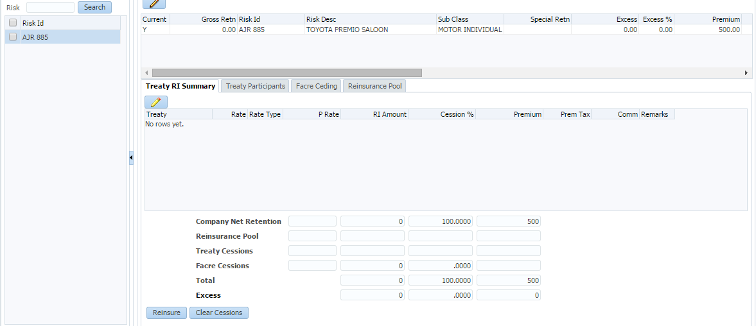

>>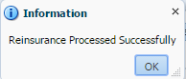

Now go to *Authorize* to authorize the policy:

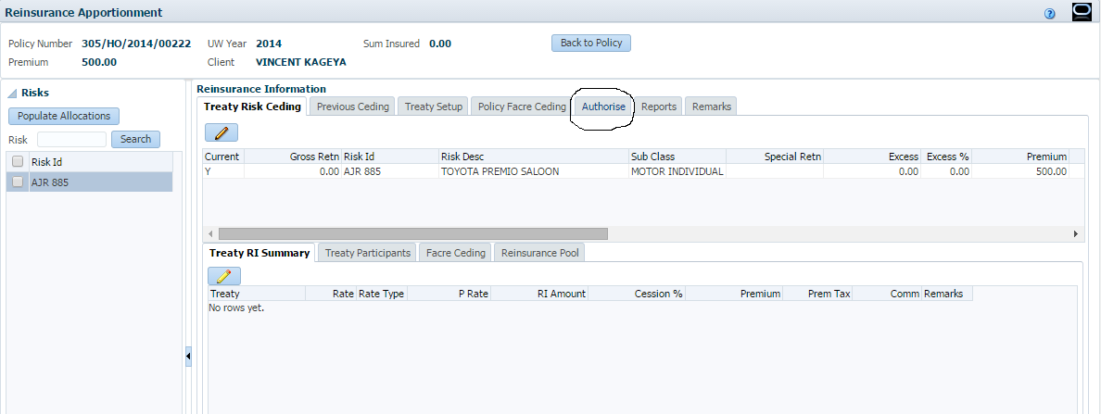

Step one: *Make Ready*:

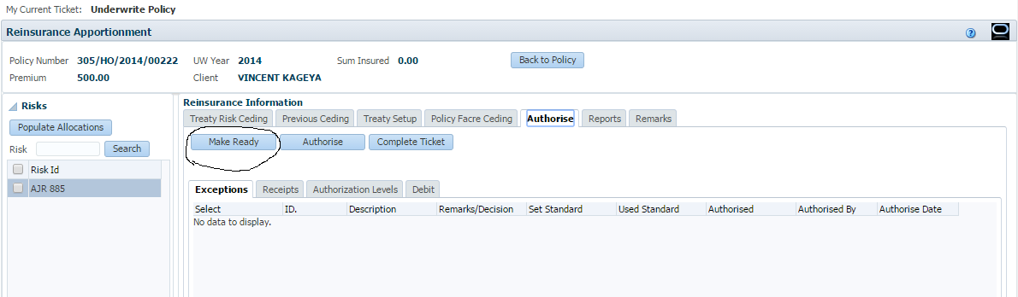

System generates exceptions which should be authorized before policy is authorized:

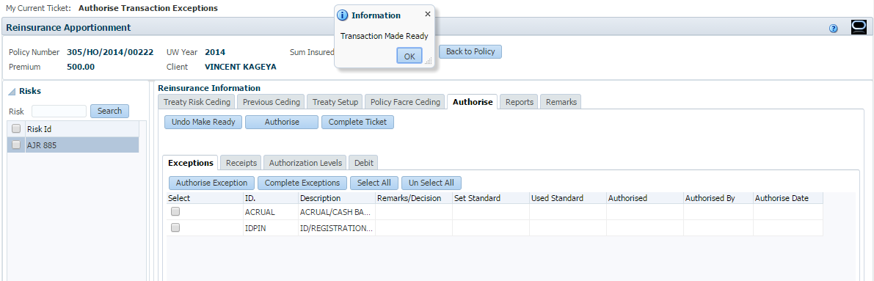

Tick on the two exceptions,

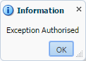

Tick on the two exceptions again, 

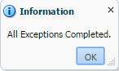

Then select  to complete underwriting this policy.

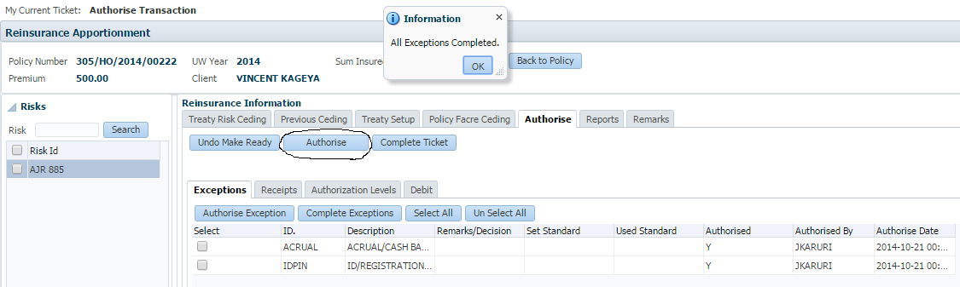

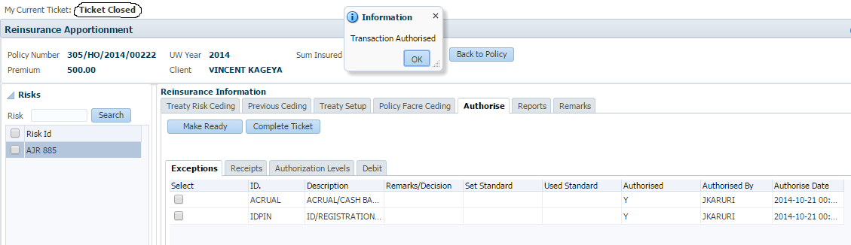

Ticket status changes to ‘*Closed*’.

You can now go to *Reports* and print the debit note for this policy:

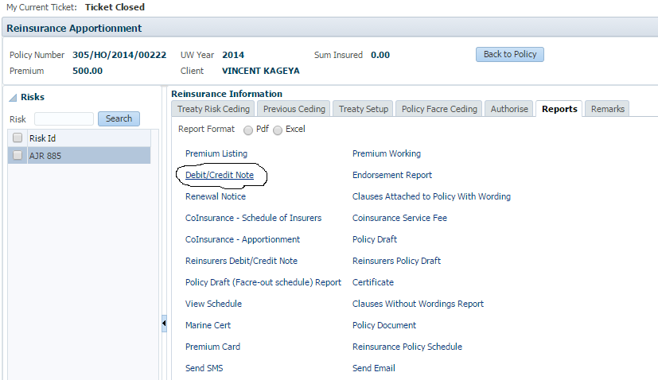

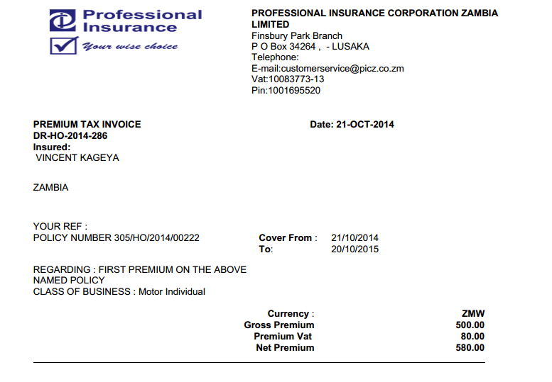

Receipting:

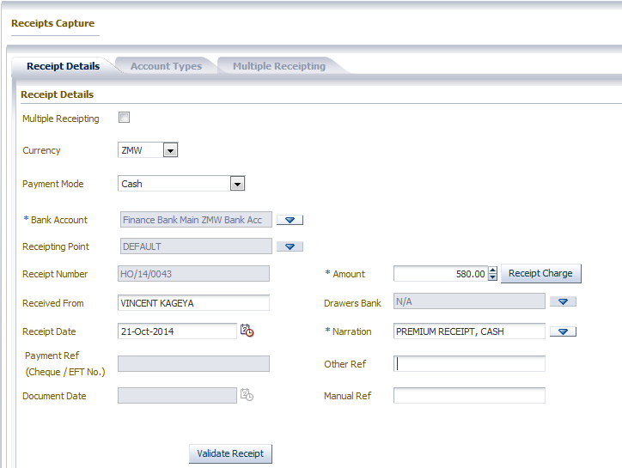

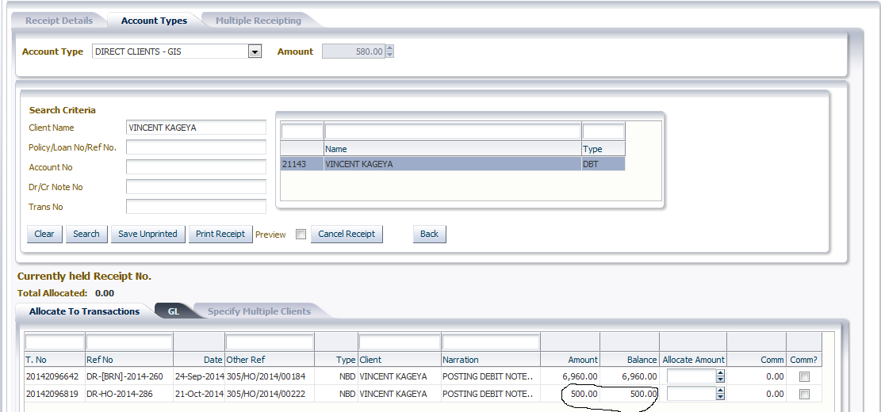

As seen above, system shows that balance on this policy is ZMW 500 instead of ZMW 580. The origin of this is in GIS, and the GIS team is working on the same.

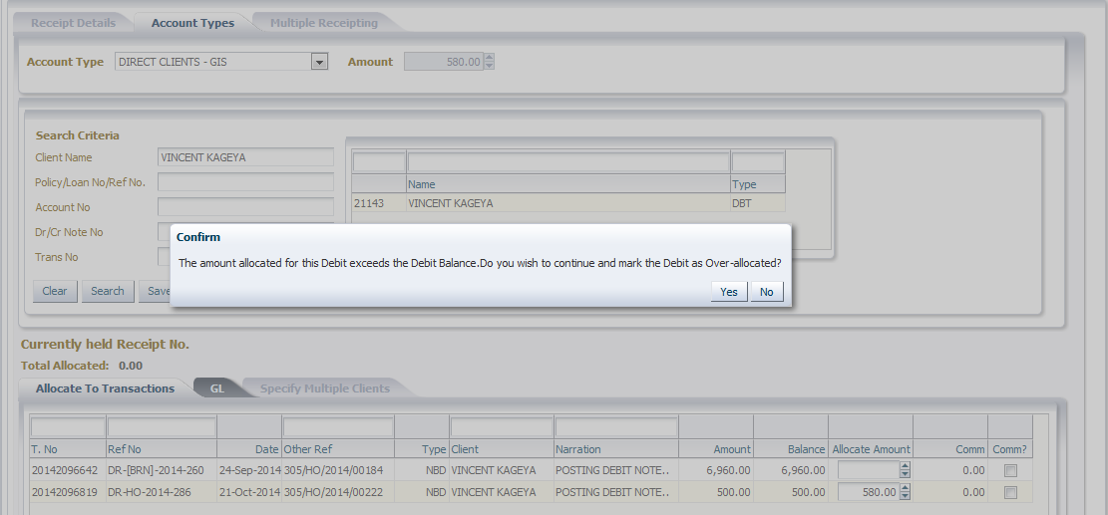

I allocate the full amount to this policy so that the full debt is cleared on the client’s statement. Receipt is printed successfully:

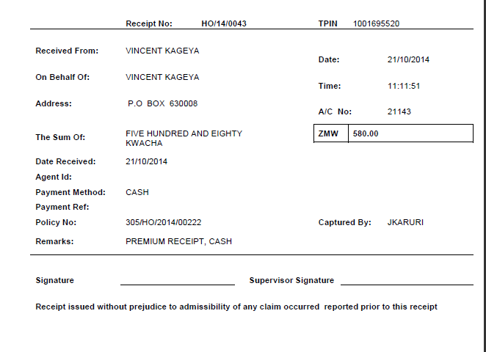

I have made some adjustments on the receipt rtf template to fit it on the pre-printed paper that PICZ are using.

Try this and let me know how it goes. There are a few things I need us to test and we might need to underwrite some policies.